W. S. K. F. ワールド松濤舘
5-26-16 Higashi-Funabashi,Funabashi 〒273-0002 千葉県船橋市東船橋
Chiba Japan 2730002 5-26-16
TEL/Fax:+81-47-767-7227 TEL/Fax: 047-767-7227

+81-90-2333-3877 MOBIL 090-2333-3877

E-MAIL:wskfjapan@world-shotokan.com 電子ﾒｰﾙ:wskfjapan@world-shotokan.com
URL: www.world-shotokan.com URL: www.world-shotokan.com

The World Shotokan Karate-do Federation

A Letter of Invitation

To the Members of the W.S.K.F.
It is a great pleasure for us invite you and your association to participate
in in the 14th World Championships, and International Training Seminar will held in Tokyo Japan on the 19-21stAugust 2019.
T This tournament is 20Years WSKF Anniversary tournament.
Please make every effort to participate in this very important event.

Please reply whether you could be present or not until 1st April 2019.
We look forward very much to your attendance and participate.

1st February 2019
Sincerely yours,
Yours sincerely,

Haruo UEDA
President of W.S.K.F.
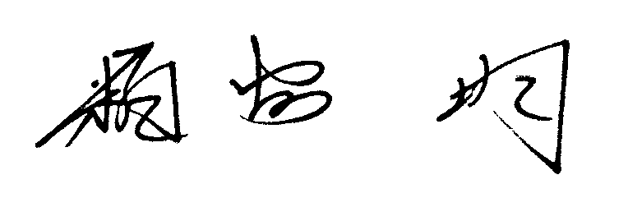

Hitoshi KASUYA
Chief instructor of W.S.K.F.
P.S.
Concerning permission to enter Japan (Visa), please contact an early stage to
Japanese Embassy of your country. Usually You will obtain entry visa a period need
2-4 weeks therefore please start early.

